Jenkins Configuation

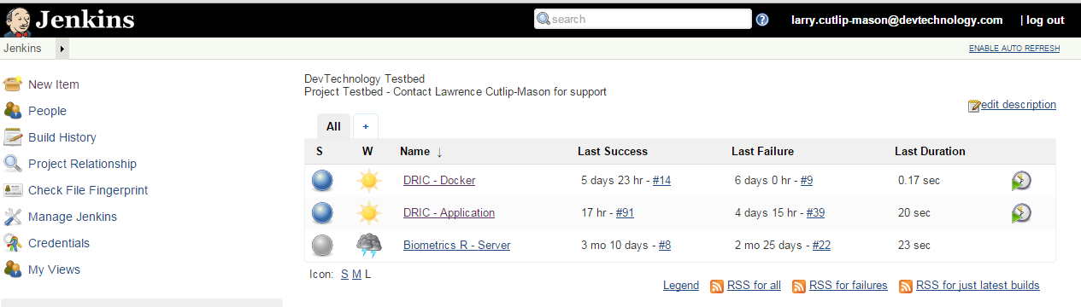

Public IP: 54.172.60.84

Private IP: 150.0.200.216

## Configuration screen

Admin can sign in using the admin user name and password

DRIC-Application is a Maven Project

Developers can use account 18fdeveloper to connect

Repository URL: [git@github.com:DevTechnology/DRIC.git](mailto:git@github.com:DevTechnology/DRIC.git)

Branches to build: */master

Excluded Regions: Docker/*

Build Triggers: Poll SCM H/5 * * * *

# every fifteen minutes (perhaps at :07, :22, :37, :52)

H/15 * * * *

Build

Root POM: api/dric-api-webapp/pom.xml

Goals and options: clean package wildfly:deploy -P wildfly-remote

* Enable triggering of downstream projects
  + Block downstream triggers when building

**Maven Validation Level:** Default

**Setting files:** Settings file in filesystem

**File path:** /usr/jenkins/settings.xml

**Global Settings File:** use default maven Global settings

Maven MOJOs

